|  |
| --- |
| Data logger for Dillon Quick-Check Tension Meter |
| Tension Logger v1 |

|  |
| --- |
| Arthur Bondar  *Electronics Technologist*  *March 14, 2021* |

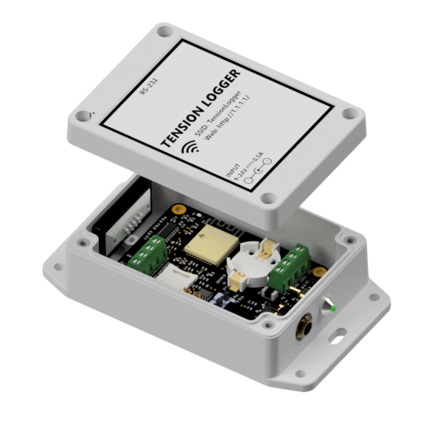

# Overview

Tension Logger is a data collection device for the Dillon Quick-Check tension meter. Communication with the meter is established via an RS232 interface. Live readings from the meter are stored internally on a memory card. The logger is equipped with Wi-Fi and employs a web-based interface for monitoring and data downloads.

Specification

|  |  |
| --- | --- |
| Wi-Fi: | 802.11 b/g/n |
| DC Input: | 9-24V 0.5A (Barrel Jack 2.0mm) |
| IP rating: | IP65 |
| Storage: | 32GB MicroSD (format FAT32) |
| Battery: | Coin Cell - CR2032 |
| COM: | RS232, UART |

Wiring  
Tension Logger uses the RS232 protocol to communicate with the Quick-Check meter. A female 9-pin D-sub connector (DB-9) is located on the logger, and a male variant is used to terminate the LIMO 4-pin cable coming from the meter. The following diagram illustrates how to terminate the LIMO cable with the correct pinout. Use the table below to solder the colour-coded conductors to the designated pins.

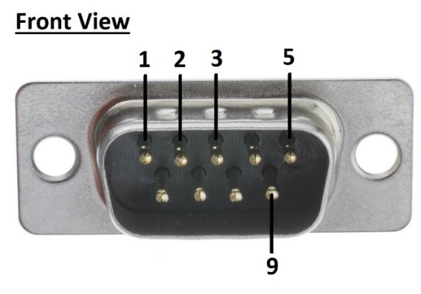

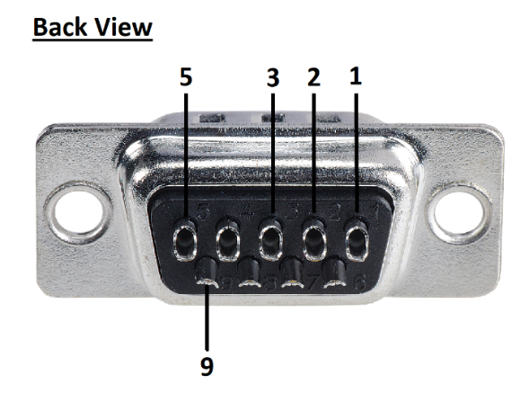

|  |  |  |
| --- | --- | --- |
| **Pin Number** | **Wire Color** | **Description** |
| 2 | White | RS232 – TX pin |
| 3 | Black | RS232 – RX pin |
| 5 | Red | Ground |
| 9 | Green | +5V supply |

Operation

Tension Logger creates a wireless access point (AP) on powerup. WiFi-capable devices such as laptops, cellphones, tablets, or PCs with Wi-Fi adapters, can connect and interact with the unit. DHCP is used to dynamically allocate an IP address for new clients. Devices connected to the logger will not have access to the internet, as the created network is internal to the logger and the device. The following table summarises the network characteristics:

|  |  |
| --- | --- |
|  |  |
| SSID | TensionLogger |
| Password | *-No password -* |
| Gateway IP | 1.1.1.1 |
| Mask | 255.255.255.0 |

Once a connection is established, the web interface page can be reached by opening a browser and typing in the IP address of the gateway: **http://1.1.1.1/**The web user interface will display live tension and provide access to the stored files on the MicroSD card.

Tension Meter Modes

Dillon Quick-Check meter sends serial data with a 1-second interval. This data is dependent on the mode that the sensor is currently in. To cycle between different modes/screens, press the Mode button on the meter.

* Mode 1 – Live Tension (default) – the meter sends live tension and units.
* Mode 2 – Peak Tension – the meter sends peak tension and units (to reset peak use the Zero button).
* Mode 3 – Average Capture – the meter sends both live and peak tension reading. Both values will be stored on the memory card.

Note: The Tension Logger is wired to provide a 5V supply to the meter, thus, the AA batteries should be removed from the compartment. For battery-powered operation, open the logger’s lid and disconnect the 5V wire (White) at the green terminal block.

Storage

Tension Logger has a 32GB microSD card formatted as FAT32 to store the sensor data in a CSV format. The logger creates a new file on powerup and writes data with a specified interval until power is available. Data can be downloaded or deleted from the card via the web interface. To physically access the storage card, remove the logger’s cover and locate the hinge MicroSD slot. Push the card towards the microcontroller to release the hinge.

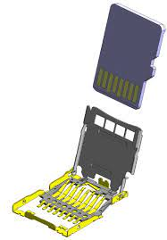

Battery

The Logger has a coin-cell 3V CR2032 battery to power the clock chip during a power-down. The clock’s time is used as a timestamp for tension reading. Time on the chip can be set via the web user interface. Note that voltage under 2.6V indicates a depleted battery, and the time will reset after replacement.

Status light

A green status LED is set to blink at a 1-second interval during normal operation. The light blinks rapidly when a new user connects or disconnects from the Wireless Access Point, and when the meter is not connected or during an error occurs.

User Interface

Page 1 – Data Display

* Status – displays a short status message.
* Date – shows the timestamp of the last live reading from the meter.
* Tension – shows the tension and the user-defined setpoint. The setpoint is used to indicate the maximum tension associated with a full dredge load.
* Progress Bar – displays the percentage of the load from setpoint via a bar graph.
* Line Graph – shows a plot of the live tension readings. The sample rate of the plot and the number of points can be adjusted on the settings page.

Page 2 – Storage

* Disk information – a quick breakdown of the disk type and used space.
* List Files – a button that generates a table of stored files on the SD card.
* File Table – provides information on the files stored on the SD card and download/delete option. Routine cleanup of the SD is recommended to prevent the list from growing too large and cause memory issues (<50 files).

Page 3 – Settings

* Update Time – used to update the “Date and Time” setting.
* Update Settings – used to update the remaining settings.
* Settings Table – list of system settings with current values and input fields.

Page 4 – Info

* Summary table of the settings parameters including min, max and description.
* List of the logger’s status messages and meaning. The status message appears on the main page.

# Settings

|  |  |  |
| --- | --- | --- |
| **Parameter** | **Value** | **Description** |
| Date and Time | Formatted | The current time on the clock chip is used to timestamp the meter readings. The time is stored during power down. Set this value after daylight savings, time zones change, or battery replacements. |
| Graph Points | 0 to 100 | The number of points plotted on the graph of the display page. Use this parameter, together with “Refresh Rate” to capture the desired amount of data on the screen. Example: 60 points at a 5-sec refresh rate will capture 5 minutes of data. |
| Refresh rate | 1 to 1800 sec | The interval at which the graph is populated with new data. Adjust this setting based on the rate of change of the load tension. Note: this setting only affects the display rate and not the storage rate. |
| Setpoint | Any integer | A user-defined tension value that corresponds to a full dredge. Provides a visual indication for the user. |
| Logging interval | 1 to 1800 sec | The interval at which the data is written to the SD card. Incoming data between the interval is ignored. (default 1 second) |